Nov. 1, 2010

Sizing Inverters for Powering Photographic Strobe / Flash Lights

1. Understanding Electrical Ratings and Parameters
1.1 “Watt” is a rating for electrical power and is equal to Voltage (Volts) x the Current (Amperes or Amps). As the voltage in a system normally remains constant, the power drawn by an electrical load could also be gauged by the current drawn in Amperes
1.2 “Watt Sec” rating is an energy rating and it is obtained by multiplying the power in Watts by the time in Sec. Please note that the energy rating in “Watt Sec” is NOT the same as the power rating in “Watt”. For example, energy rating of 320 Watt Sec can mean 320 Watts of power for 1 Sec or 3200 Watts of power for 1/10 Sec of 32,000 W of power for 1/100 sec etc
1.3 An AC power source like utility / grid power or a pure sine wave inverter outputs a voltage that has a waveform like a sine wave as shown in Fig. 1 below:

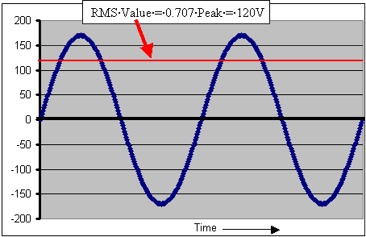
Fig. 1 Characteristics of Sine Wave Form
For example, in one cycle, the RMS voltage in 120 VAC, 60 Hz AC power rises slowly in the Positive direction from 0 V towards the peak Positive value of 170 V, slowly reduces to 0 V, changes to the Negative direction, slowly rises to peak Negative value of – 170 V, and slowly reduces to 0 V. There are 60 such cycles in 1 sec. Time taken for each cycle is 1/60 Sec or 16 milliseconds. 1 cycle consists of ½ Positive cycle of 8 milliseconds and ½ Negative cycle of 8 milliseconds. As the voltage is changing with respect to time, a derived equivalent steady state value of voltage called the Root Mean Square (RMS) voltage is used which has a value of 0.707 times the peak voltage. In the figure above, the peak value of 170 V corresponds to 170 X 0.707 = 120 V RMS

2. Charging Characteristics of a Capacitor
2.1 A capacitor is used to store electrical energy. The energy stored in a capacitor is directly proportional to its “Capacity Rating – usually in Microfarads. When a fully discharged capacitor starts charging, it initially consumes an extremely high surge current and acts almost like a short circuit. The charging surge current reduces exponentially as the capacitor charges fully. The initial extremely high charging surge current is directly proportional to the charging voltage and the capacity of the capacitor in Microfarads
3. Principle of Operation of Photographic Strobe / Flash Light
3.1 A strobe / flash unit basically consists of the following:
3.1.1 A sealed glass tube lamp filled with Xenon gas that produces a high intensity burst of light when the gas is ionized due to very high voltage electrical energy fed across the ends of the tube.
3.1.2 A bank of capacitors that store low voltage electrical energy that is rated in “Watt Sec” as explained at paragraph 1.2 above. When the strobe / flash unit is triggered, this stored low voltage electrical energy in the capacitors is converted to a very short (around 1/1000 of a Sec) pulse of very high voltage energy and this high voltage energy is used to trigger the Xenon lamp
3.1.3 The light output of the strobe / flash is measured in “Candlepower Sec”. The conversion of the electrical energy in “Watt Sec” to the light energy in “Candlepower Sec” depends upon the efficiency of conversion of the particular strobe / flash unit.

3.1.4 The nature of the charging current (and consequently the Watt power as explained at paragraph 1.1 above) drawn by the strobe / flash unit can be analyzed when seen on an oscilloscope (Please see paragraph 4 below). It is seen that during re-charging, the current (power) drawn by the capacitors in the strobe / flash unit is in the form of very short duration pulses of around 1millisecond duration occurring 120 times per second (one pulse every ½ cycle of the 60 Hz sine wave). The peak value of the current pulses is extremely high in the first 100 milliseconds and tapers off to almost zero in around 2 to 3 seconds after the capacitors are fully charged (Please see Fig. 3 below). Hence, during the initial 100 milliseconds or so, the RMS power drawn for charging the capacitors can reach approximately 4 times the Watt Sec rating of the strobe / flash (Please the explanation under Fig. 2 below).

4. Voltage and Current Waveforms during Re-charging
4.1 Voltage and current waveforms of a typical 250 Watt Sec strobe / flash unit (OPUS Pro Series, Model No. OPL-H250 www.opusprophoto.com ) powered from a 600 W inverter are shown below:
4.2 The screen shots given below have been obtained using Tektronix Oscilloscope Model TDS2012 with the following settings:
- Channel 1: AC output Voltage of the inverter (Yellow, sinusoidal waveform)
    - External Tektronix Differential Voltage Probe Model P5200; Attenuation setting: 500 X (1/500)
    - Oscilloscope probe attenuation: 1X (No attenuation)
    - Volts per Division: 200 mV
      - Effective Volts per Division: 100 V (200 mV X 500 magnification = 100 V)
- Channel 2: AC output current drawn by the strobe / flash unit (Blue, non linear wave form)
  - External Tektronix AC/DC Current Probe Model A622 set at 10 mV per Amp
    - Oscilloscope probe attenuation: 1X (No attenuation)
  - Volts per Division: 100 mV
  - Effective Amps per Division: 10 A (100 mV / 10 mV per Division = 10 A)
- Time scale:
  - 10 milliseconds for screen shot of initial 100 milliseconds shown in Fig. 2 below
  - 500 milliseconds for screen shot of 5 sec shown at Fig. 3 below
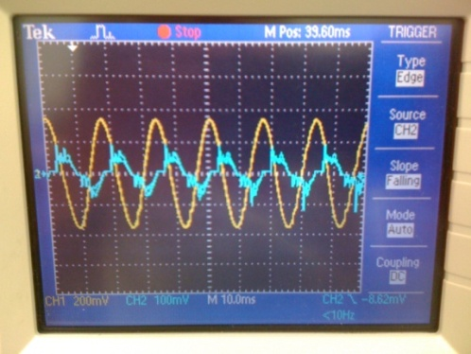
Fig. 2 Screen shot of the initial 100 milliseconds of recharging of 250 Watt Sec strobe/ flash unit showing pulsing current with very high initial peaks

Voltage reading: Sinusoidal wave form, 60 Hz
(Channel 1) Peak Voltage = 169 V, RMS Voltage = 120 VAC

Current reading: Non linear, pulsing wave form, 60 Hz, one peak every half cycle
(Channel 2) Pulses with Peak Current = 12 A or RMS current of 12 A / 1.414 = approximately 8.5 A Duration of peak approximately 1 milliseconds. The RMS power during the first 1 to 2 millisecond is 120 V X 8.5 A = 1020 VA which is approx 4 times the Watt Sec rating of the strobe / flash unit

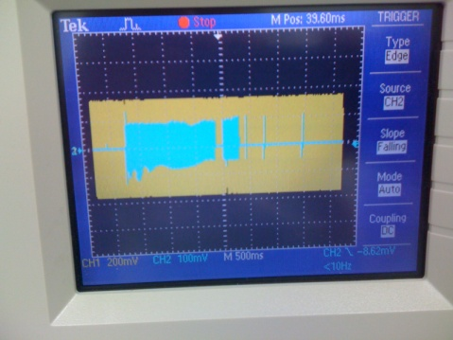

Fig. 3 Screen shot for 5 Sec to show complete recharging of 250 Watt Sec strobe / flash unit

Voltage reading: Sinusoidal wave form, 60 Hz
(Channel 1) Peak Voltage = 169 V, RMS Voltage = 120 VAC

Current reading: Non linear, pulsing wave form, 60 Hz, one peak every half cycle
(Channel 2) Pulses with Peak Current = 12 A, Recharging duration approx. 1.85 Sec
5. Power Ratings of Inverters
5.1 The power output of an inverter is rated as follows:
5.1.1 Continuous Power: This is the power that can be provided by the inverter continuously
5.1.2 Surge Power: This is the power the inverter can provide for a very short period of time. This time is usually not specified by the manufacturers. As a thumb rule, this time may be assumed as < 1 Sec. Please note that the inverter may NOT shut down at an overload that is much higher in value than the rated Surge Power if this overload occurs for an extremely short duration of a few hundreds of milliseconds. If this happens repeatedly, the inverter is likely to fail prematurely. In such cases, the surge power rating of the inverter should be higher than the maximum surge likely to be seen by the inverter even if this surge is very fast
6. Overload protections in Inverters
6.1 Inverters are protected against overload as follows:
6.1.1 Complete shut down on overload: The inverter will shut down completely if the continuous power or surge power ratings are exceeded. The inverter will latch in the shut down condition. A manual reset will be required by switching off the unit and switching on again. The inverter provides full rated output voltage till it shuts down due to overload
6.1.2 Drop output voltage on overload: The inverter will not shut down but its output voltage will drop to limit the output power to within the safe operating area. The output voltage will recover automatically once the overload is removed. The drop in the output voltage is obtained by clipping the upper and lower portion of the sine wave. This clipping action converts the sine wave into a square wave and thus, creates a lot of harmonics and electromagnetic noise that may be harmful for the sensitive devices connected to the inverter. This type of shut down may be used for devices that are not sensitive to AC input voltage drop, can withstand square wave / modified sine and are not affected by higher values of harmonics and electromagnetic noise
7. Proper sizing of inverters based on their overload protection characteristics
7.1 In view of the very high inrush charging surge power consumed by the strobe / flash units as explained at paragraph 3.1.4 above, the following guide lines are recommended for sizing the inverter:
7.1.1 For inverters with overload protection characteristics that ensures full rated output voltage of 120 VAC / 230 VAC under overload condition of up to their rated surge power rating (paragraph 5.1.2 above) - The rated RMS Surge Power rating of the of the inverter in Watts should be more than 4 times the Watt Sec energy rating of the strobe / flash unit. For example, if the energy rating of the strobe / flash is 320 Watt Sec, the surge power rating of the inverter should be more than 320 Watt Sec X 4 = 1280 W. An inverter with surge rating of around 1280 W or above will thus be suitable for this strobe / flash – e.g. Samlex America, Inc. inverter Model No. PST-60S-12A that has a continuous rating of 600 W and a surge rating of 1200 W
7.1.2 For inverters with overload protection characteristics that drops the output voltage under overload conditions and does not shut down (paragraph 5.1.2 above) - The rated continuous power rating of the of the inverter in Watts may be less than the Watt Sec energy rating of the strobe / flash unit.
CAUTION! This type of overload characteristics of the inverter produces reduced output voltage and distorted output waveform under overload as detailed at paragraph 5.1.2 above and is likely to damage the strobe / flash. Please confirm with the manufacturer of the strobe / flash for compatibility

